Project Utilization Report – Jama 4.0 – Report Setup

SQL Backend

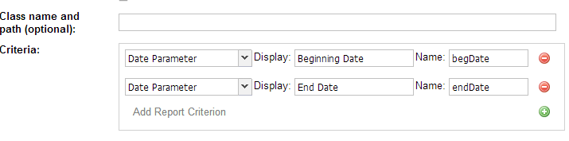

MySQL and Oracle Backends

